Wellness Week 2018

Warhawks for Wellness

Monday, December 3rd, Mental Health Monday
WEAR GREEN FOR MENTAL HEALTH AWARENESS!
Warhawk Time: Wellness Screening Grades 10 & 12
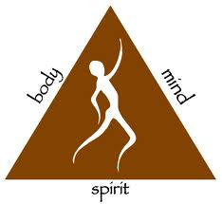
Warhawk time activity Grades 9 & 11

Tuesday, December 4th, Workout Wear
WEAR SWEATS OR TRACK SUITS
Warhawk Time: Knockout Competition- Main Gym
Yoga – Wrestling Room
Relaxation – Dance Room
Coloring, Board Games & Play-Doh – Cafeteria
Stress Relief Activities- Warhawk Hall

Wednesday, December 5th, Pajama Day
STAY COZY AND WEAR YOUR PAJAMAS
Warhawk Time: Speaker – Auditorium

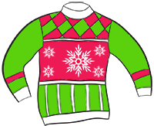
Lunches: Therapy Dogs – Courtyard

Thursday, December 6th, Ugly Sweater Day
WEAR AN UGLY SWEATER
Warhawk Time: Backyard Games – Main Gym
Meditation – Wrestling Room
Coloring, Games, Play-Doh & Stress relief activities – Cafeteria
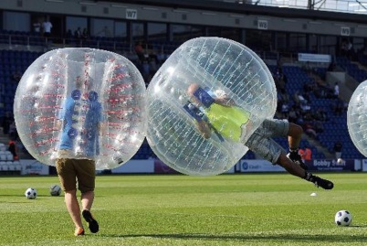
Lunches: Ugly Sweater Competition

Friday, December 7th, Flannel Friday
WEAR FLANNEL
Warhawk Time: Teacher Bubble Soccer – Main Gym

**9th grade wellness projects will be on display in the library throughout wellness week. Please encourage your Warhawk Time students to come down and browse.

